Stephen Laycock  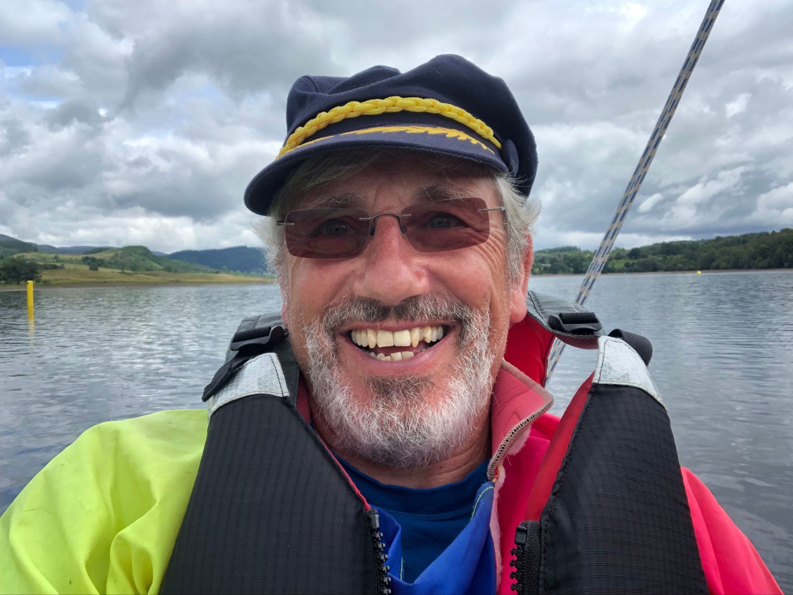  chairman@sailabilityscotland.org.uk  www.sailabilityscotland.org.uk | 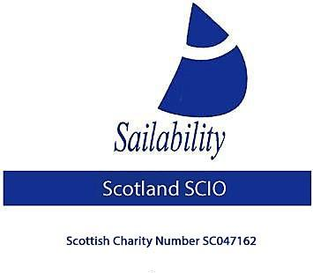

Tack Tick
For 15th February 2022

Our AGM has been arranged for Sunday 3rd April to be held at Monklands SC, Hillend reservoir, Caldercruix, meeting will start at 10:30am. All interested parties are invited. Light refreshments will be served afterwards.

PLEASE forward to me any points you wish to be raised at the meeting – only written point will be discussed.

Our finalised dates for this year’s regattas are displayed in the table below,

T1 | April 22nd, 23rd, 24th | Loch Venacher SC
T2 | May 28th, 29th | Kippford SYC
T3 | June 25th , 26th | Loch Earn SC
T4 | July 9th, 10th | Monklands SC
T5 | August 13th, 14th | Bardowie SC
T6 | August 27th 28th | Lochaber SC SOCC
 | September 4th | Round Shuna event (not part of championship series)

In addition, the following events will be held in England

26th 27th February | RYA Dinghy Show
19th 20th March | Exmoor Beastie
6th 7th May | Burghfield Regatta
11th 12th June | Grafham Regatta
16th 17th July | Welsh Open (Llyn Brenig Regatta)
5th 6th 7th August | Rutland RYAS Multiclass Regatta
23rd 24th 25th Sept | Rutland Challenger UK Championship
1st 2nd October | Ogston Open

At our committee meeting on 13th February, I was very pleased to be able to announce the following: -

- Mr Paul B Moore (Commodore Monklands Sailing Club) has joined Sailability Scotland and after being proposed and seconded became our newest Trustee.

- On 22nd December 2021 Mrs Veronica E Abernethy wrote to me with an offer of a donation from Dr TMN Salvesen’s Charitable Trust (SC021073) of £15,000 to be given to Sailability Scotland to be used for general charitable purposes. I accepted this incredibly generous offer and on the 2nd February the funds were transferred electronically into our account.

Here is an excerpt from her letter

“This is from a charitable trust set up by my father, Dr TMN Salvesen, who died in 2006. My brother, David Salvesen, Nephew Will Taylor-Jackson and I have the privilege of being trustees of this charity. Our father was a keen sailor throughout his life and would be proud to support the work of your charity.
”

- I have written to Mrs Abernethy offering our most sincere thanks for this generous donation.

We are now faced with decisions as to what to do with this money.

All suggestions will be considered.
SL suggested is that we use this money to leverage more funds from the National Lottery. If we can obtain a grant under “match funding” we can double the value of this donation. To this end SL has already made enquiries and has been advised that Sailability Scotland SCIO fulfils all necessary criteria to make an application. SL would be to use this fund to improve our Monklands offering to disabled sailing by: -

- Improve access within the secure boat yard grounds by landscaping and the provision of concrete pathways
- Provide a new floating jetty to replace the existing and unsafe one.
- To purchase a safety boat
- To drive a new road from the clubhouse over a wetland to improve water access (the land is owned by the club)

With the committee’s approval SL will continue with covering the groundwork to the National Lottery.
Committee approved further investigation.

SL asked for his comments on the announcement.
Paul Moore requested a copy of the thankyou letter sent to Mrs Veronica E Abernethy of the Dr TMN Salvesen’s Charitable Trust (SC021073) to be able to present it to his Monkland’s committee.
SL suggested that after talking to Scottish Enterprise he thought a co-operative where all parties are equal and remain financially independent would-be best way forward. Scottish Enterprise has indicated to him that they are expert at this kind of thing and that they offer free legal advice and legal documentation to set up a co-operative. PM agreed this sounded like the way forward and indicated that this idea would be put to his Monkland’s sailing group committee meeting to be held later this week. A further meeting needs to be set up when all stakeholders would be invited to send a representative to discuss.

A long discussion ensued about how best to use the TMN Salvesen’s Charitable Trust (SC021073) donation.

Finally
I am sad to inform you of the death of Derrick Robinson 1928-2022.
Derrick was a faithful member of CCC, Beachmaster and Bosun looking after and maintaining our fleet of Challengers which at one time numbered 14.
He had been presented with the RYA Volunteer of the year Award.
He served as Chairman of RYA Sailability Scotland for several years and also loved sailing his own yacht Quicksilver of Rhu on the west coast of Scotland, but he will particularly be missed by the UK Challenger fraternity.
His funeral was held at Clydebank Crematorium, Glasgow on the 2nd of Feb. and afterwards at the West Highland Gate in Milngavie.

Steve Laycock
Chairman
Sailability Scotland SCIO

