Tack Tic
May 2021

Dear Members
From both a professional and a personal point of view this last 18 month has been a time like no other before it, Chaos followed by turmoil followed by change, uncertainty and yet more change, restrictions on what we can and cannot do and fear of catching the virus leading many to become self-imposed prisoners.
I feel deeply for all those that have lost those close to them in this pandemic, especially because restrictions have not allowed us to gather and grieve in the way in which we have always been accustomed.
BUT, we must look forward to better times and even though life is as yet far from normal we can take a great big dollop of hope in that the newly developed vaccines will enable life to be able to be lived again.
With that in mind, I can report that while virtually no organised sailing took place in Scotland last year things have been happening behind the scenes.
My first duty is to report that following on from our AGM held in March our newly elected trustee James Donaldson who was subsequently elected to act as secretary has resigned as both the secretary and as a trustee. Jim’s reasons were given to me and I fully understand his decision. Because of this the charity is currently a post holder short! If anybody feels they could fill the role (with my and the other trustees support) I would be incredibly grateful if they could step up. Our constitution allows us to co-opt a person to this role without having to be elected at an AGM.

My second duty is to inform you that as soon as travel restrictions that had been in place for nearly a year were lifted, we were able to uplift a single trailer and a double trailer from Monklands and start work on their maintenance. As you know all boats have been stood for a considerable length of time and therefor their condition had deteriorated somewhat. I would urge those of you that are custodians of Sailability boats to do your utmost to maintain the boats, at the very least submit a report on their state of repair to me asap.
Of the 3 boats that were retrieved from Monklands
“Scottish Flame” was refurbished by our ex-secretary Duncan Greenhalgh and delivered as soon as cross border restrictions were lifted to our newest member who has leased her for a year. Charles Thornton sails out of Ullswater but hopes to join us for some of the traveller events.
“Hotscotch” and “Great Scot” are being renovated and refurbished by myself and further work is being done on the boats at Loch Vennacre and by Duncan on the lease boat in the care of Stephen Thomas Bate. In all fairness I think we have done a good job on these boats, but the maintenance program must continue. As due to pandemic restrictions we have been unable to raise any funds this year, the cost of the maintenance program has been fully funded by the kind donation from Sir Boyd Tunnock OBE
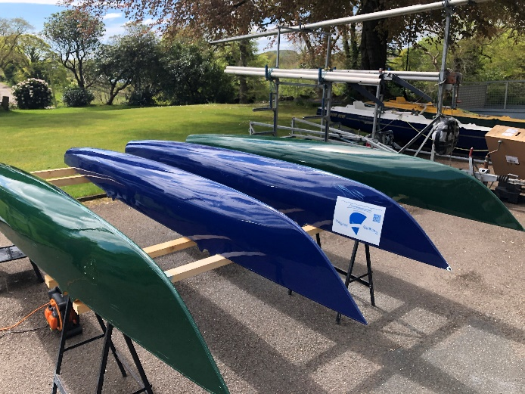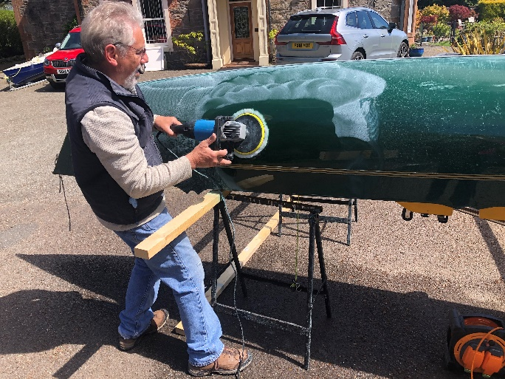
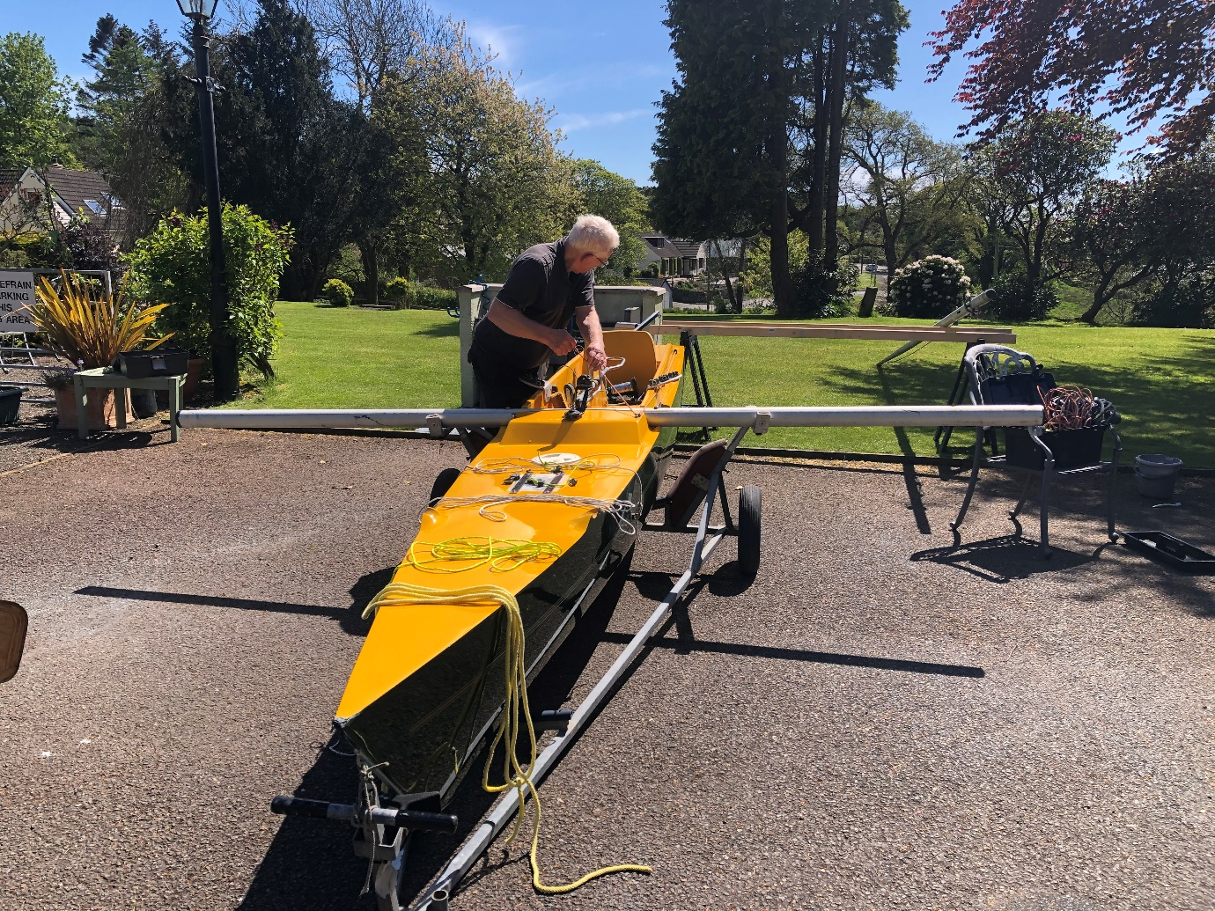

Now, the all-important bit. What about sailing events for 2021? As you may know or at least can imagine we are not going to be able to put on a full series of events this year, with covid restrictions still not fully lifted and with some uncertainty surrounding the governments next steps all we can do is make semi solid plans. I have been informed that certain clubs are not prepared to host this year as the provision of toilet facilities/catering/changing and accommodation are all still affected by pandemic related restrictions. However, the good news is we have managed to secure 2 possible 3 events, as follows:
Event | Location | Start Date | End Date | Status | Notice Of Race and links
T1 SOCC | SYC Kippford | 11th July | 12th July | Confirmed | ..\Sailability_Scotland\2021\SYC 2021 Challenger Open Poster new pic.docx  ..\Sailability_Scotland\2021\SYC NOR 2021 Scottish Challenger Open Championship v2-1.docx  mailbox:///C:/Users/steve/AppData/Roaming/Thunderbird/Profiles/9yuvbqcl.default/Mail/Local Folders/Personal.sbd/Sailing.sbd/Sailability Scotland?number=142&part=1.3&filename=ACCESSIBLE%20ACCOMMODATION%20IN%20THE%20AREA.docx
T2 | Loch Vennecre | 31st July | 1st August | Confirmed
T3 | Bardowie | 14th August | 15th August | Provisional (Covid restrictions in Glasgow area are under revue)

