Stephen Laycock  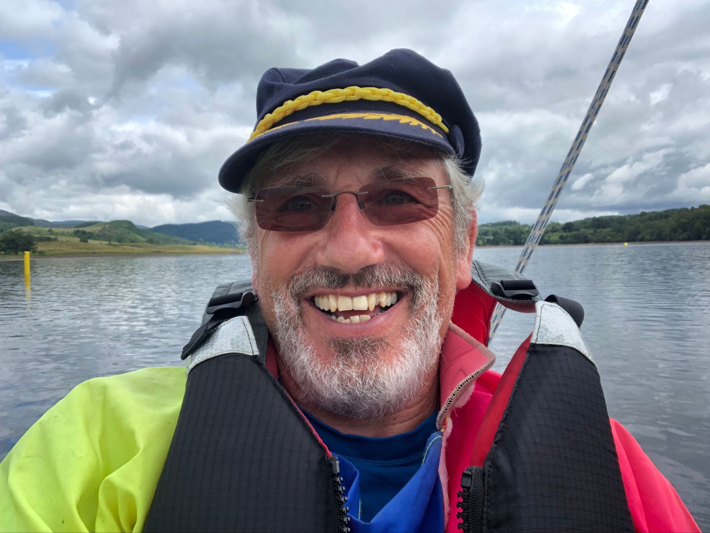  chairman@sailabilityscotland.org.uk  www.sailabilityscotland.org.uk | 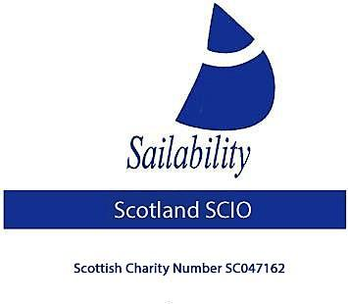

Tack Tick
For December 2021

Greetings one and all to the December edition of Tack Tick.

I KNOW! Its that time of year when everybody is winding down, looking forward to a happy holiday and instead we get all those unsolicited emails from every Tom Dick and Harry that we ever had anything to do with “Wishing you a Merry Christmas”, well this isn’t one of them! LOL

This Christmas Wish comes from your erstwhile and diligent Chairman! . Not just a Christmas wish but here’s hoping for a Happy New Year too! I can hold out some hope that we will have a happier New Year as “Good News” is, I have managed to arrange next seasons regatta series! Please save these dates to your diary.

April 22nd, 23rd, 24th | Loch Venacher
May 28th, 29th | SYC (Kippford )
June 25th , 26th | Loch Earn
July (date yet to be confirmed ) | Monklands
August 13th, 14th | Bardowie
October 1st, 2nd | Lochaber SOCC

You will note that Monklands SC is on the list! I can confirm that the work on the Dam has been started and is scheduled to be completed early in the new year (Come on, That’s GOOD NEWS!!)

Also, I can confirm that the Charity has received a donation of a “VIRUS Plus 16 Trimaran” This boat is in need of a little TLC but I have accepted it because with its seating capacity of 3 adults or 2 adults and 2 children it will make a great training boat. I have already arranged for this boat to be leased out in the new year, More Good News!

I can report that I have completed the accounts for the year ending 30th Nov 2021 and that these have been examined and signed off by our independent auditor and subsequently submitted to OSCAR. They can be viewed here http://www.sailabilityscotland.org.uk/Accounts.html

Even More Good News!! Stephen Thomas Bate has agreed to take over as Treasurer in the new year.

I can also tell you that we have had enquiries from two clubs wishing to set up new Sailability Sections and in addition, we’ve had 3 individuals wanting to lease boats in the New Year! That would be very “Good News” if only we had a stock of boats and trailers, we could lease out. In order to try and meet demand I have transported two boats from their long-term storage at Monklands and will be transporting a further boat from Lochore Meadows early in the new year with a view to updating both them and their trailers to ensure that they are in good condition to sail and be safe.

Very last Item on the list! We need to arrange our AGM. I propose that we hold it at Monklands in early February, precise date yet to be confirmed. PLEASE forward me any points you wish to be raised at the meeting – only written point will be discussed.

I lied, VERY LAST POINT.

Merry Christmas to each and every one of you, “may your sails never sag and your rudder be true”

Steve Laycock
Chairman
Sailability Scotland SCIO

