Stephen Laycock  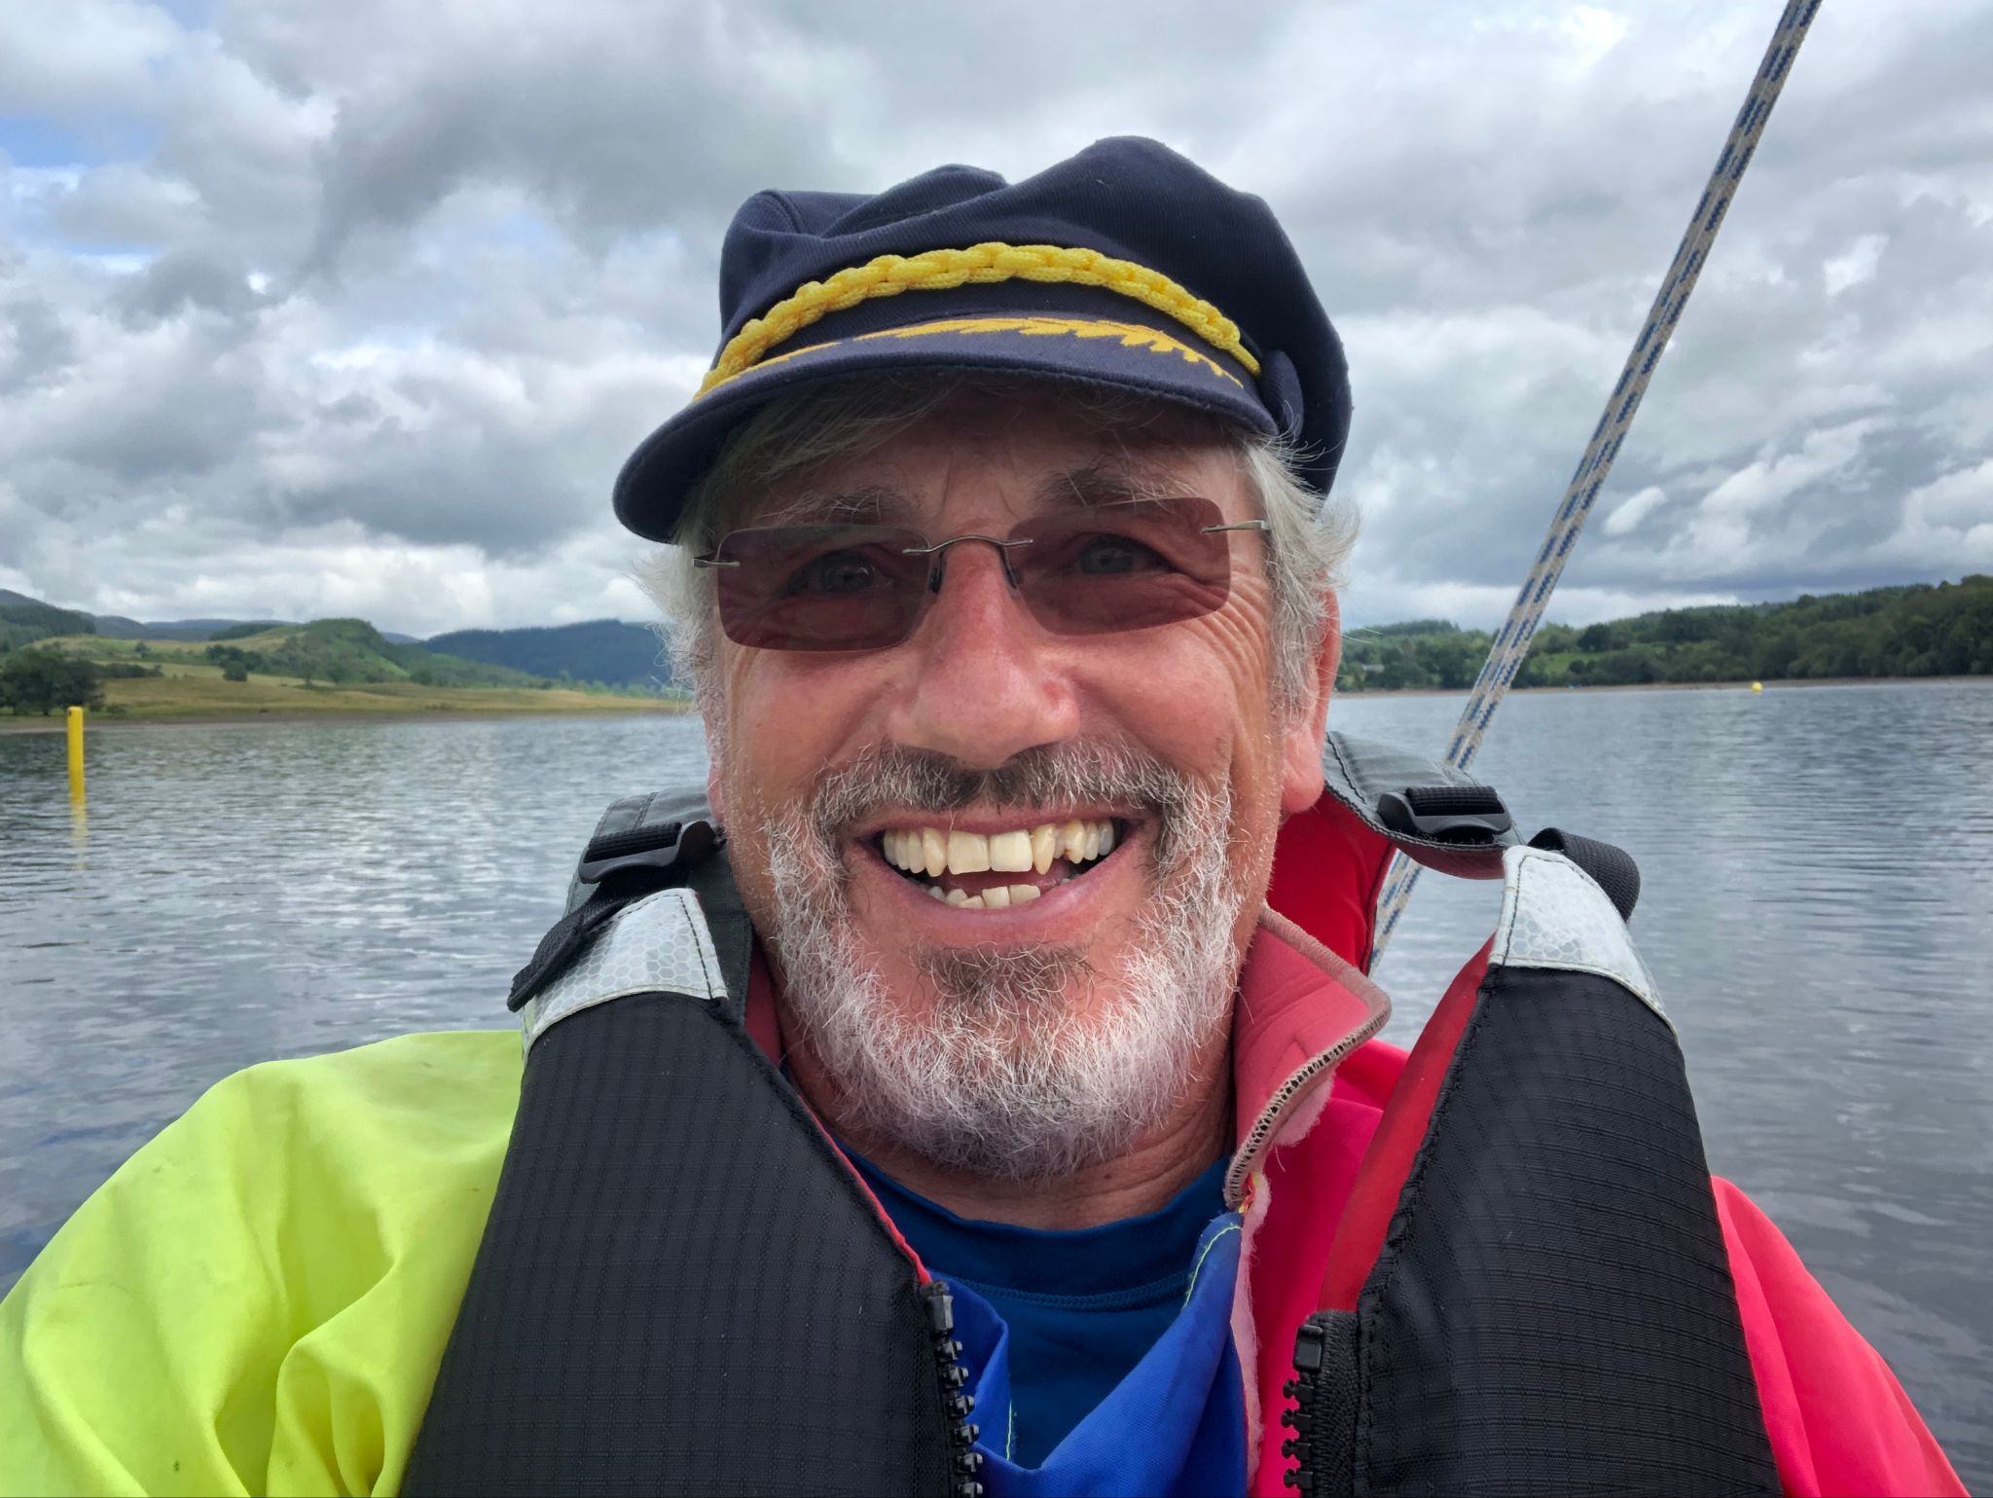  chairman@sailabilityscotland.org.uk  www.sailabilityscotland.org.uk | 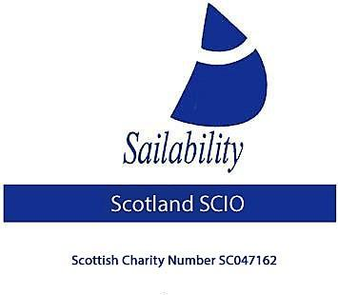

Tick Tack
For 12th April 2022

A Cautionary Tale
Last week I became aware that two “Aero Rig” Challengers located at Staunton Harold Reservoir in Derbyshire were no longer required there and so needed a new home. These boats belong to “The Challenger Class Association” but transfer of ownership was being offered F.O.C.
After discussing this with our treasurer we decided that these boats would be a good fit in our Monklands offering. So, after arranging with the Staunton Harold chap (Mark Harden) and with Graham Hall (Trustee Challenger Class Association), I made arrangements to go down and pick them up. I was told that they both had a road trailer but that “The Challenger Class Association” wanted to keep one of them, so I set off down on Friday to collect just one boat. From my house to Staunton Harold is 252 miles, a journey which should take just over 4.5 hours. However, due to injury I am currently not allowed to sit for more than 30 min without a 10-minute break. So, the journey took 6 hours.
Now, at this point I should make it clear that I had no concerns about pulling the trailer back as I was convinced that in the event of any breakdown my RAC membership had me covered. I had previously asked for my cover to include towing trailers and indeed I had previously broken down while pulling a trailer and had been transported car and trailer on a flatbed lorry to my destination which was a 175-mile journey.
I arrived at Staunton Harold at 16:30 (it was Easter Holliday weekend so traffic had been heavy) Mark had kindly put the boat onto a trailer and it was all ready for me to tow away. I was surprised to find it was on a double trailer but that wasn’t an issue. We checked it all round put a couple of extra staps on and said thankyou very much. It was now far too late to set off back I was too tired anyway to contemplate another 6-hour drive so we booked in at the nearest hotel we could find with a vacancy.
In the morning and after breakfast we spent another hour going round the trailer and retying ropes and tensioning straps until we were happy that it was safe to set off home.
We had driven just 20 mile and were on the A50 which is a VERY busy dual carriageway when we heard an unfamiliar noise, for a second, we thought it was a change in road surface but as the noise changed pitch, I recognised the trailer had suffered a catastrophe. Thankfully I had been in the inside lane travelling at just 50 mph, I completed an emergency stop but the dual carriageway had no hard shoulder and was bounded on the inside by a wide and deep concrete storm drain, consequently I could only get the car and trailer nearside wheels a few inches off the carriageway. Such had been the noise that I dare not continue the further 60 yards or so to get into a nearby SOS layby.
Through my rear view mirrors, I could not see what the problem was, I could not get out of the driver’s door as traffic was thundering past and missing me by millimetres and because of my disability and injury I could not climb out of the passenger side. I immediately used the cars SOS feature to call the police and they arranged to send someone out.
My partner Jean had got out of the car (with our dog) and was frantically waving a red and white shopping bag at the oncoming traffic trying to warn them of the hazard they were approaching. With no central reservation the carriageway had nowhere for vehicles to go, chaos ensued. Two lanes of practically continuous traffic were having to squeeze into 1.25 lanes with almost no warning. I shut my eyes and pressed my head against the headrest and tucked my arms into the seat belt. It took 35 minutes which were the longest 35 minutes of my life.
Joy, the highways van pulled up some 30 meters behind us with all its light flashing. He got out and promptly started deploying signs and cones, so now, all traffic had to slow down and use just the one lane. It was now safe for me to open the driver’s door, so I got out and inspected the trailer. Its nearside wheel was sitting at a 20-degree angle and still on the wheel hub despite all 4-wheel bolts having disappeared!
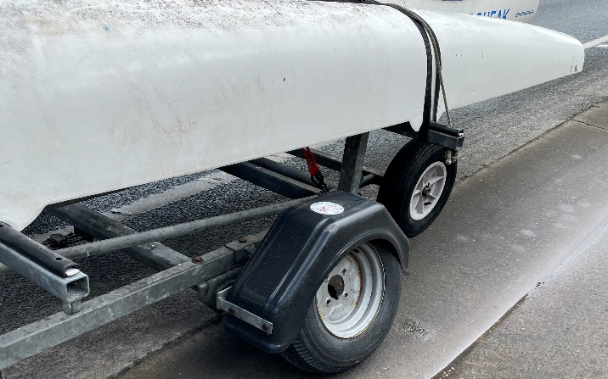
The highways man informed me that if he touched anything it would cost me a minimum of £150, but he could arrange for a rescue with a flat bed trailer to come and take me away. HOWEVER, he warned, NOBODY would pick me and or the trailer up from the position it was in as it was so unsafe. He advised the best thing to do was to get to a place of safety whether that meant dragging the trailer with one wheel off to the layby or taking two bolts of the good wheel and putting them on the nearside wheel. Wanting to avoid his charges and having a hydraulic jack and a complete socket set in the car I opted for taking two nuts off the “good” wheel and putting them on the “bad” wheel. After I did this, we were able to roll the car and trailer slowly forward into the nearby SOS layby, unbelievable relief, we were now in a “SAFE PLACE”.
The highways authority flat bed lorry arrived in the layby, and he informed me he could take us to his depot but that it would then be locked up until Monday with recovery and storage charges. I contacted the RAC and to my surprise they informed me that they would come out but that my breakdown cover did not cover the trailer breaking down. If the car had broken down, they would uplift both me and trailer and transport us to my final destination but as it was the trailer that had broken down it was not covered. They would still pick me up and transport me and the trailer home but at a cost of £1320. I declined their offer.
The Highways man and the flatbed lorry man departed and as they had not actually done anything they did not raise any charges.
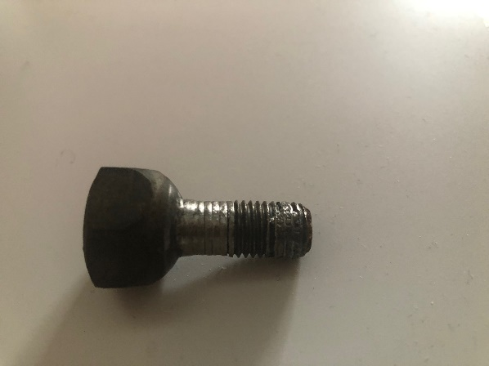
The man from the RAC arrived in his van and tried his very best to find some wheel nuts from the box of hundreds he had in his van. No luck, he said he had never seen a wheel nut like it. So, he set off walking back along the carriageway (extremely dangerous despite his high viz jacket and flashing van lights), to see if he could find any of the missing bolts. Amazingly he did find one, photo attached!
On scrutiny it was his opinion that the 4 nuts had come adrift because (looking at the retrieved nut) it would appear only the middle part of the thread had been holding. He tested his theory by using a metered torque wrench on the two good bolts I had put in. According to him they should tighten up to (I think he said 90 pounds-feet, but I may have this figure wrong) but at 90 (p-f) the two bolts continued to turn and would not tighten up. He said this probably ment the internal thread on the wheel hub had been stripped and that therefor the trailer was not roadworthy even if 4 new bolts could be found.
It was at this point I decided enough was enough. All three roadside assistance men had advised it was not safe to travel with only four bolts between two wheels and now I was being advised the trailer itself was not roadworthy. I felt I had no option left but to return the trailer and boat to Staunton Harold reservoir. Very kindly the RAC man escorted us almost all the way back to Staunton Harold Reservoir SC, travelling at 30mph it felt like a long way.
I informed Mark Harden I had returned the boat and once again set off home, thankfully this time without incident.

The lesson learnt
Always check before you tow that your breakdown cover includes for the trailer to breakdown and that both are covered for transport to your final destination.

Steve Laycock
Chairman
Sailability Scotland SCIO

