www.sailabilityscotland.org.uk | 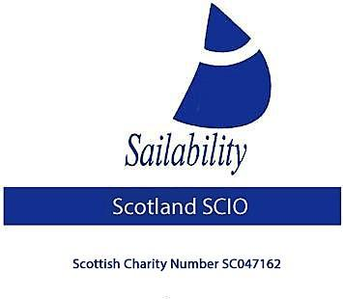
Tick Tack for 31st October 2022

Hello members,
We have reached the end of another interesting and exciting racing season.

Traveller Challenger Series and Regatta News
We held 5 traveller series regattas in 2022. Unfortunately, the last regatta that was due to be held at Bardowie (T6 Duncan’s Regatta) was, unfortunately cancelled a few days before the event was scheduled, due to excessive wind being forecast. Our understanding is that the Commodore of Bardowie made the decision to cancel on the grounds of safety for the sailors, committee, and support crew.

Congratulations go to Duncan Greenhalgh, who retained his championship this year. He has now won three consecutive championships (2019, 2021 and 2022). There was no event in 2020 due to the Covid-19 pandemic.
The final series results for 2022 are shown below.
Sailor | T1 Loch Earn Sailing Club | T2 Solway Yacht Club | T3 LESC  Loch Earn Sailing Club | T4 Castle Semple | T6 Lochaber Yacht Club  (SOCC) | Points | Position
Duncan Greenhalgh | (4) | 3 | 1 | 1 | 1 | 6 | 1
Ronnie Cameron | 6 | 5 | 3 | (7) | 5 | 19 | 2
Dorothy Bennett | 8 | 18 (DNC) | 5 | 6 | 4 | 23 | 3
Alex Hodge | 7 | 18 (DNC) | 2 | 4 | 18 (DNC) | 31 | 4
Stephen Thomas Bate | 5 | 18 (DNS) | 4 | 5 | 18 (DNC) | 32 | 5
Val Milward | 1 | 1 | 18 (DNC) | 18 (DNC) | 18 (DNC) | 38 | 6
David Driffell | 3 | 2 | 18 (DNC) | 18 (DNC) | 18 (DNC) | 41 | 7
Nick Bett | 2 | 4 | 18 (DNC) | 18 (DNC) | 18 (DNC) | 42 | 8
N.B. 2 events must be completed to qualify as a valid entry in the final championship table.
It is an amazing result for Ronnie Cameron who finished in 2nd place overall. He is an absolute inspiration. He is 92 years young and still showing a clean pair of heals to the younger sailors. He always has a smile on his face and is as fit as a fiddle. We need to wrap PopeyeRon in cotton wool and hope that he sails forever.
The following sailors also entered events (we had 17 competitors in total in 2023), and we hope to see them competing in 2023. These do not qualify for the overall series table, having only completed one event:
Arthur Black , John Hasler, Iain Hardy, Stephen Laycock, Hamish Loudon, Rory McKenna, John McPartlin , Craig Moffet, and Jules Whitestone.

General Handicap and Challenger Open
2 Scottish-based sailors competed at the English Open, held at Ogston, Derbyshire on the 1st and 2nd October 2022. Congratulations to Duncan Greenhalgh and Stephen Laycock for flying the Scottish Saltire. See the full report in Yachts and Yachting
https://www.yachtsandyachting.com/news/254614/Ogston-Handicap-and-Challenger-Open

UK Challenger Championships
A fantastic 3 day sailing event for the UK Challenger Championships took place between the 23rd and 25th September 2022. 4 Scottish-based sailors took part in the event. Stephen Thomas Bate and Duncan Greenhalgh have made the 250 trip from Dumfries and Galloway for a number of years. This year, they were accompanied by Rory McKenna and his friend from university, Chichian Wu from Chinese Taipei. It was wonderful to see Rory enter, as he is normally a Hansa sailor. The full report can be found in Yachts and Yachting by clicking on the link below:
https://www.yachtsandyachting.com/news/254288/UK-Challenger-Championships-2022-at-Rutland

Round Shuna
Four Challengers entered the annual Round Shuna pursuit race, organised by Clyde Corinthian Yacht Club on the 4th September, 2022.

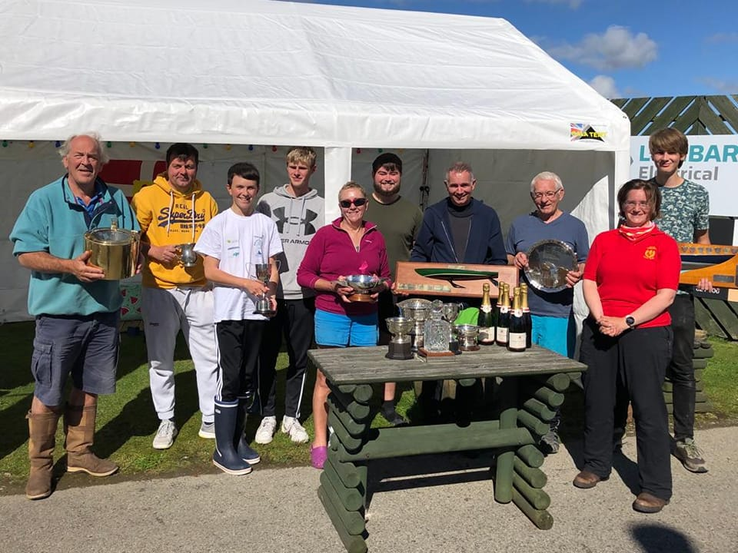
Congratulations to Duncan Greenhalgh in winning the Camus Marine Quaich, being the first Challenger home. He sailed the course in 1 hour and 26 minutes, with the other three competitors close behind. Click on the link below for the full results:
https://www.clydecorinthian.org/article/round-shuna-race-weekend-2022-results

WOCCs
Two of our Scottish-based sailors entered the Welsh Open Challenger Championship at Llyn Brenig Sailing Club, North Wales, on the 16th and 17th July 2022. Sadly, this event is often poorly-attended due to the remoteness of the club. However, this is a fantastic venue, being the highest inland water above sea level in the UK. The scenery is spectacular and the club facilities are exceptional. It is a very hearty recommendation to sail here.

There were only 4 competitors this year, with 2 hailing from Scotland. Duncan Greenhalgh finished 3rd, whilst Stephen Thomas Bate finished in last place (4th).
There were some lovely trophies on offer for the competitors.
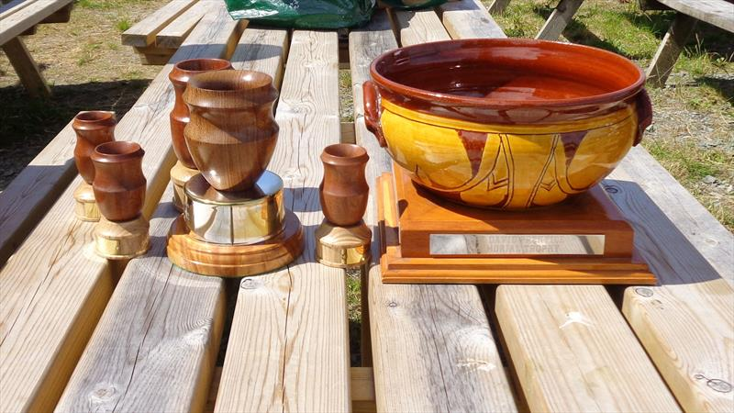

Read the event report in Yachts and Yachting by clicking on the link below:
https://www.yachtsandyachting.com/news/251745/Welsh-Open-Challenger-Championship

Stephen Thomas Bate (STB)
Trustee
Sailability Scotland SCIO

AGM 2023
Now the sailing season is over for another year, thoughts turn to the 2023 season and our AGM. The AGM for 2023 will be held in March or April next year. Your Chairman Stephen Laycock, and Dorothy Bennett will be standing down, as it is the end of their 4-year tenure ship.
At this point in time, it is difficult to see where any new trustees might come from. In the event no new trustees are found then the charity can continue with the 3 remaining trustees. This is not ideal and to avoid this happening, it was suggested at our last committee meeting that the maximum term a person can be a trustee for, be increased from 4 to 6 years. This would require a change to the constitution.
At that committee meeting, we agreed that an Extraordinary General Meeting (EGM) would need to be called later this year to amend the constitution. This would be a one-off amendment, allowing the two retiring committee members 2 additional years in office, due to the Covid-19 lockdown. The members would have to vote to accept or reject the proposed amendment. If the resolution passed, it would allow the term those trustee’s served to be increased from 4 years to 6 years. Thereafter, once the current incumbents reach the end of their terms, the years of office would return to 4 years. The exact wording of this proposal would be forwarded to members in early November to give sufficient notice for the EGM to be held in late November/early December.
Two justifications exist for this proposal:
- To ensure that the charity does not collapse at the next AGM through a lack of trustees.
- During the Covid-19 pandemic, no sailing took place for almost two years. Therefore, there was very little work that the trustees could undertake, as they were all on hiatus, so it could be argued that they did no work during that period.

However
This would mean that as a trustee and having fulfilled the role of:
2019 Treasurer, Webmaster, Fund Raiser
2020 Treasurer, Webmaster, Fund Raiser, Bosun
2021 Chairman, Treasurer, Secretary, Webmaster, Fund Raiser, Bosun
2022 Chairman, Treasurer, Secretary, Webmaster, Fund Raiser, Bosun

I could commit to continue.
I undertook to be a trustee 4 years ago and have fulfilled that commitment. Considering my other commitments, I now need to step down at the forthcoming AGM. Additionally, the Charities constitution makes it clear that the Charity can operate with a minimum of 3 trustees, which means that it is not in immediate danger of collapsing.

Having made the decision not to seek to continue in office, the proposed change to the constitution would no longer seem to fulfil any purpose.

It is the committee’s responsibility to do all that they can to ensure the charity continues. So, members are urged to encourage anyone they deem suitable to come forward and volunteer to work with Sailability Scotland SCIO to help it continue to provide help and support to disabled sailors in Scotland.

Planning for next year’s traveller series

I have asked Duncan Greenhalgh to take on this task and he has kindly accepted. Today 02/11/22 I have forwarded an email drafted by Duncan to all members and supports and additionally to all sailing clubs past and present (those I hold email addresses for) asking for suggestions/offers of support towards arranging next year’s series. IF YOU HAVE ANY SUGGESTIONS, PLEASE email Duncan Direct on Duncan.greenhalgh@outlook.com

Result of the Suitability Assessment of the,” Virus” Trimaran

As has been previously reported, at the end of 2021 the Charity was gifted a “Virus” trimaran. This had been left outside for a number of years and needed some considerable TLC to clean it up. It also needed two trampolines designed and made as the originals were missing. The first set of trampolines failed within a minute of setting sail leading to further delays in trialling this boat. The 2nd set did not become available until the end of July. We sailed her only 4 or 5 times with a variety of disabled sailors.
The results
- The boats “seacock” needs replacing – a relatively minor issue but it needs doing before the boat is sailed again
- It is difficult to raise the gaff rig without an able-bodied person actually stood in the boat.
- The low boom means sailors must either sit on the bottom of the boat or on the trampolines. Sitting on the deck is uncomfortable, sitting on the trampolines means changing sides at each tack and ducking under the low boom to accomplish this, not many disabled sailors can do this.
Regretfully then I/we have concluded that this boat is not suitable for disabled sailors and therefor should be disposed of to recoup monies spent on its refurbishment.
Steve Laycock – Chairman
*************************************************************************

Other sailing news

Golden Globe
A story about Susie Goodall’s Golden Globe race in 2018 has been published. It is a fascinating insight into the race, her preparations, emotions, trials and adversity. It takes around 1 hour to read, but is a very interesting story.

Before the race
Watch Susie’s pre-race thoughts:
https://youtu.be/yQZnQKHZ_jI

Alone at the Edge of the world
https://magazine.atavist.com/alone-at-the-edge-of-the-world-susie-goodall-sailing-golden-globe-race/

The rescue
https://www.bbc.co.uk/sport/sailing/46484919

Vendée Glove 2024
The next instalment of the Vendée Globe round the world race will take place in 2024. The race is undertaken in single-handed 60’ monohull IMOCA. The race starts at Les Sables d'Olonne in western France, heads south down the Atlantic Ocean, turns to port around the Cape of Good Hope on the tip of South Africa, heads east past Cape Leeuwin, onto Cape Horn in South America, along the Antarctic continent and the Antarctic Exclusion Zone (AEZ) to starboard, before heading back north up the Atlantic, before finishing at Les Sables d’Olonne.
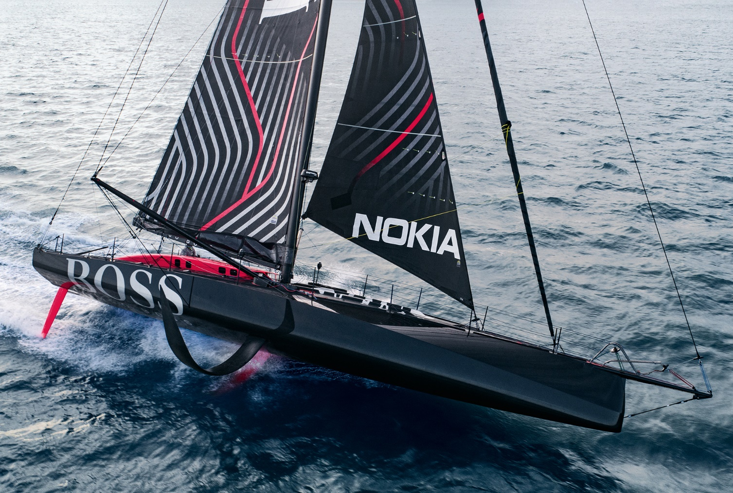
Alex Thomson sailing Hugo Boss in 2021
The leading yachts are expected to finish in around 80 days (around the world in 80 days?). 4 British sailors took part (1 man and 3 women).
Follow the full story of 2020 by clicking the link below:
https://www.vendeeglobe.org/en/webdoc
The full results from 2020 can be found by following the following link: https://www.vendeeglobe.org/en/tracking-map
If you fancy a bit of a challenge, entries are now open for the 2024 edition. Notice of Race.

Stephen Thomas Bate (STB)
Trustee
Sailability Scotland SCIO

