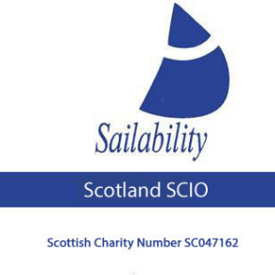

**SOLWAY YACHT CLUB**

**SCOTTISH OPEN CHALLENGER CHAMPIONSHIP (SOCC) 10TH / 11TH MAY 2025**

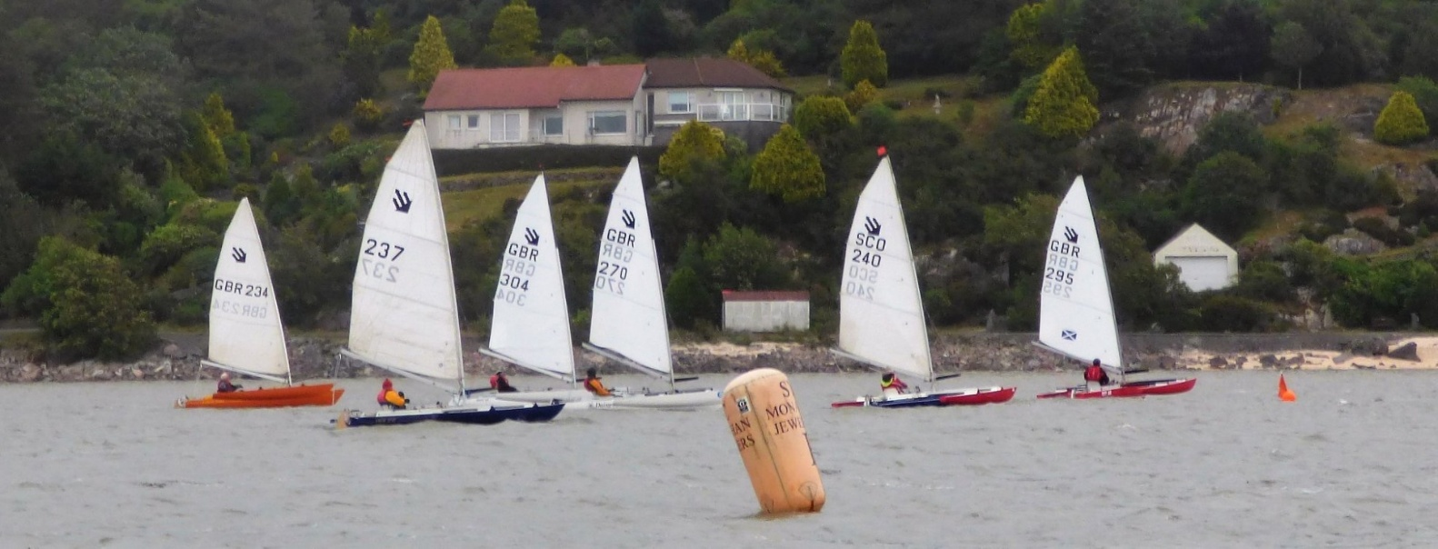

Friday 9th May: Registration 19.30 – 20.30. Saturday 10th May: Late Registration 08.00, Briefing 08.30, 1st Race 0945, High Water 11.15, Challenging Dinner 19.00

Sunday 11th May – 1st Race 10.20, High Water 11.50, Prize-giving 14.45

The Organising Authority is the Solway Yacht Club in association with Sailability Scotland.

The event is being generously sponsored by Sir Boyd Tunnock of Tunnock Biscuits.

Solway Yacht Club, The Clubhouse, Kippford, Dalbeattie, Dumfries and Galloway DG5 4LL

Tel: 07768 809862

[www.thesyc.com](http://www.thesyc.com)

**WELCOME**

Solway Yacht Club invites you to join us for a weekend of wonderful sailing in a setting of outstanding natural beauty. Racing for the weekend will take place in the more sheltered area stretching from where the river begins to open out to the fringes of the Solway Firth. The estuary gives competitors the exciting experience of sea sailing but in an area sheltered from the strongest winds. Tides and currents add to the mix. The large and comfortable clubhouse is in an elevated position with views over to Glen Isle. The Clubhouse changing rooms on the ground floor with ramp access will be available to competitors and the Club has arranged for the use of the Kippford Village Hall between the Clubhouse and boat park where the Club will hold the Briefing, Dinner event and Prizegiving. Disabled Persons’ toilet facilities are also available at the Village Hall.

**ACCOMMODATION & PARKING**

There are many hotels and boarding houses within easy walking or motoring distance as well as caravan, camping and holiday chalets nearby, but early reservations are advised. A list of local accommodation that might be accessible is attached to this Notice of Race. There is limited parking for Campervans/Caravans at the Clubhouse which needs to be arranged in advance with the Sailing Secretary.

There is limited car parking space at the club site and the public car park. For the safety of competitors and spectators, vehicles may not be driven onto the pier area and boat park other than to drop off or collect boats.

Access to the Club boat park will be provided between 14.00 and 20.00 on Friday 9th May and from 07.45 on Saturday 10th May. Access outside these times may be arranged by contacting the Sailing Secretary.

**USE OF CLUB FACILITUES, CATERING & BAR**

Competitors and supporters will be made Temporary Members of The Solway Yacht Club for the duration of the Championship.

SYC expects that bacon butties will be available to the competitors from the Village Hall prior to racing on the Saturday morning and tea and cakes at the prize-giving on the Sunday afternoon. The club intends to hold the “Challenging Dinner” in the Village Hall on the Saturday evening, 1900 for 1930, with tickets at a discounted price for those booking them in advance of the weekend that will be open to all competitors and supporters, as well as club members.

Competitors will be able to use the Club changing rooms and showers, though these are not suitable for

disabled persons access.

**HOW TO FIND US**

Kippford lies to the south of Dalbeattie along the A710. From the west, follow the A745 and then the A711 from Castle Douglas to the boundary of Dalbeattie. From the north, follow the A711 from Dumfries until the far end of Dalbeattie.

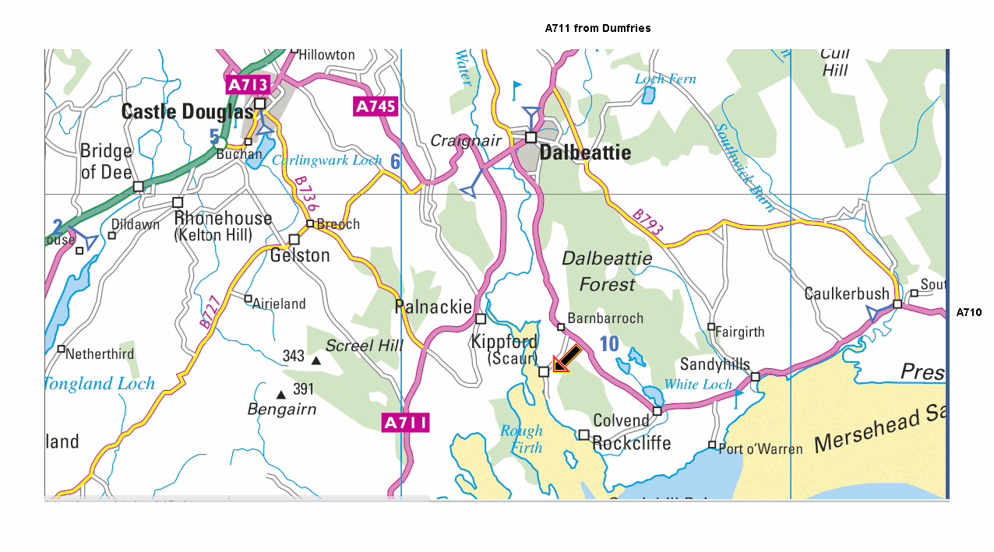

For both, now take the A710, which is signposted

“Solway Coast”. Follow this road for around 3 miles and then turn right signed for Kippford. The Clubhouse is just before the foot of the hill on the left and the boat park is on the right just round a sharp left corner.

**CONDITIONS**

1. The meeting will be open to members of the Challenger Class Association, Sailability Scotland and members of the RYA, or a RYA recognized Yacht Club, sailing a borrowed boat.

2, The racing will be governed by the Racing Rules of Sailing (RRS) 2025 - 2028, the event Sailing Instructions and the Challenger Class Association rules. In the event of conflict, the event Sailing Instructions and any posted amendments to them shall prevail.

3. The entrant will be deemed to be the helmsman named on the entry form.

4. Changes of hull or sail from those described on the entry form will not normally be allowed, but in event of damage or other circumstances must be notified to and approved by the Principal Race Officer and / or Sailing Secretary prior to commencement of the race or races in which they are being used.

5. Personal buoyancy in compliance with EN393 or better mustbe worn by all competitors and their “buddies”, if sailing with one, while afloat. Boat buoyancy may be subject to scrutiny. A suitable painter or tow rope of at least 8m mustbe carried on all boats to facilitate towing and rescue.

6. A tally system may be used to ensure all competitors return safely after racing. If so, all competitors are obliged to use the system and to cooperate fully with its requirements.

7, Each Challenger must have a grab line of free specification fitted toeach sponsonand a dedicated tow

line or painter of at least 8m in length and having a suitable diameter that is led back to the cockpit.

8. Entry and Consent form must be completed online. In addition, where the competitor (helm or “buddy”) is under 18, a paper copy must be completed, signed by the parent or guardian and delivered to the Club Race Office prior to or at the Briefing on the Saturday.

9. Dogs should be kept on a leash at all times while on SYC premises.

10. Car numbers should be kept to a minimum and should be parked in the club or public car parks and are not

allowed onto the boat parking area once the series has started other than to deliver and collect competing

boats.

11. In the event of a contradiction between this Notice of Race and the Sailing Instructions, the Sailing Instructions will apply. The Sailing Instructions will made available online in the same way as the Notice of Race prior to the event and paper copies made available at the Briefing.

12. Sailing is by its nature an unpredictable sport and therefore inherently involves an element of risk. By taking

part in the event, each competitor agrees and acknowledges that:

1. They are aware of the inherent element of risk involved in the sport and accept responsibility for

the exposure of themselves, their crew and their boat to such inherent risk whilst taking part in the event.

1. They are responsible for the safety of themselves, their crew, their boat and their other property

whether afloat or ashore.

1. They accept responsibility for any injury, damage or loss to the extent caused by their own actions or omissions.

d) Their boat is in good order, equipped to sail in the event and they are fit to participate.

e) The provision of a race management team, support boats and other officials and volunteers by

the event organiser does not relieve them of their own responsibilities.

1. The provision of support boat cover is limited to such assistance, particularly in extreme weather conditions, as can be practically provided in the circumstances.
2. It is their responsibility to familiarise themselves with any risks specific to this venue or this event drawn to their attention in the SIs or at the Briefing, which they should attend.

**RACING PROGRAMME**

|  |  |  |  |  |
| --- | --- | --- | --- | --- |
| **Day** | **Date** | **Briefing** | **Warning 1st Race** | **HW** |
| Saturday | 10th May | 08.30 | 09.45 | 11.15 |
| Sunday | 11th May | 09.20 | 10.20 | 11.50 |

The Sunday Briefing will be a very short one held at the Pierhead for competitors planning to sail that day.

Warning times shown are the times of the warning signal at the Start Line. Sailors should be aware that it can take some time to reach the racing area, so please ensure boats are ready for launching in sufficient time. In the event of light winds, tows will be available to help competitors reach the starting area, hence the need for carrying suitable tow ropes/painters. Our Motor and Sailing Cruiser fleet will be starting a cross-Solway “Cruise in Company” on the Saturday, returning on the Sunday, and Club Dinghy and Flying Fifteen racing will also be taking place, so launching and recovery will be under the control of an appointed Piermaster, whose instructions should be obeyed to ensure everyone gets afloat in good time.

If the entry is 8 or more boats, it is planned to hold 2 races per day from a committee boat stationed in the northern part of the estuary with the club fleet(s) starting from the same line after the Challenger fleet. If the entry is 7 or less, or a Committee Boat start is not feasible for whatever reason, the Club Line at the Start Hut will be used instead.

**SCORING SYSTEM**

The low points system as provided in RRS Appendix A will apply. There will be 1 discard if 4 races are sailed. The

minimum number of races to constitute a series will be 2.

**PRIZES**

SOCC Championship Trophies will be awarded and will include “The Sandeman Trophy” for the overall Winner, “The Clyde Cruising Club Trophy” for the Winner of the last race, “The Helensburgh Challenger Quaich” for the top Scottish Helm and “The Consular Corp Trophy” for the top Lady Helm. Other prizes will be awarded at the discretion of the Organising Authority dependent on the number of entries.

**ENTRIES, ENTRY DEADLINE AND FEES**

Entries must be made via Webcollect using the Link: <https://webcollect.org.uk/syc> and fees paid via Paypal, Bank Transfer or by cash or cheque payable to Solway Yacht Club at Registration.

The Medical and Consent form must be completed online. In addition, where the competitor is under 18, a paper copy must also be completed, signed by the parent or guardian and handed in at Registration.

Entries will close at 24.00 on Thursday 9th May 2025.

**Entry Fee:** £15.

**INSURANCE**

Each participating boat must be insured with valid third-party insurance with a minimum cover of at least £3,000,000 per incident or the equivalent.

**SAILING AREA**

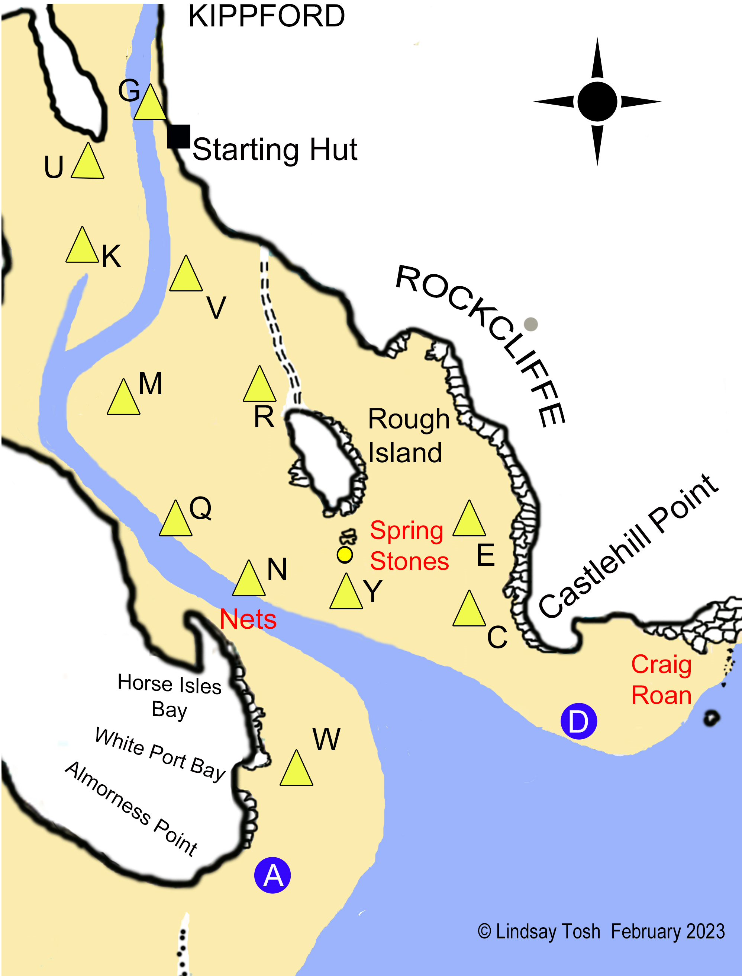

**Note:** The main channel now runs SW from G, past K, instead of taking the curved route shown above.

Any queries to John Broadbent, Sailing Secretary, on 01556 630424 or [sailingsec@thesyc.co.uk](mailto:sailingsec@thesyc.co.uk)

**ACCESSIBLE ACCOMMODATION IN THE AREA**

**N.B. This list is not comprehensive and may not be up-to-date. The Solway Yacht Club will not take any responsibility for the suitability or quality of the establishments listed.**

**The Clonyard Hotel,** Clonyard Hotel, Colvend Nr Dalbeattie, DG5 4QW

Tel: 01556 630372

Email: [info.clonyard@yahoo.com](mailto:info.clonyard@yahoo.com)

<https://www.clonyardhotel.co.uk/>

**Barend Holiday Cottage,** Sandyhills, Dalbeattie, DG5 4NU

Tel: 01387 780663

Email: [info@barendholidaylodges.uk](mailto:info@barendholidaylodges.uk)

<https://www.visitscotland.com/info/accommodation/barend-holiday-cottage-p869831>

**Grooms Cottage,** Arbigland, Kirkbean, Dumfries & Galloway, DG2 8BQ

[Tel: 01556](Tel:01556) 504030

Email: [info@discoverscotland.net](mailto:info@discoverscotland.net)

<https://www.visitscotland.com/info/accommodation/grooms-cottage-p2144971>

**Barend Lodges,** Sandyhills, Dalbeattie, Dumfries & Galloway, DG5 4NU

Tel: 01387 780663

Email: [info@barendholidaylodges.uk](mailto:info@barendholidaylodges.uk)

<https://www.visitscotland.com/info/accommodation/barend-holiday-lodges-p869821>

**Kings Apartment,** St Andrew's Street, CASTLE DOUGLAS, Dumfries & Galloway, DG7 1EL

Tel: 01556 504030

Email: [info@discoverscotland.net](mailto:info@discoverscotland.net)

<https://www.visitscotland.com/info/accommodation/kings-apartment-p1058531>

**Criffel Glen,** Kirkbean, New Abbey, Dumfries, DG2 8AB

Tel: 01556 504030

Email: [info@discoverscotland.net](mailto:info@discoverscotland.net)

<https://www.visitscotland.com/info/accommodation/criffel-glen-p1012171>

**Kendoon Apartment,** Kippford, Dalbeattie, DG5 4LL

Tel: 01556 620001

Email: [johndee61@btinternet.com](mailto:johndee61@btinternet.com)

<https://www.visitscotland.com/info/accommodation/kendoon-apartment-p1314021>

**Woodsedge Kirkennan,** Kirkennan Estate, Palnackie, DG7 1PE

Tel: 01566 600438

Email: [jenny@kirkennan.co.uk](mailto:jenny@kirkennan.co.uk)

<https://www.visitscotland.com/info/accommodation/woodsedge-kirkennan-p1111571>

**Note:** There is a lot of other tourist accommodation available in Kippford and the area around, details perhaps most easily being found online using search engines such as Tripadvisor.

Hotels, B&Bs, etc. can be heavily booked even in May, so early booking is advised.